ASSIGNMENT-1
//1st
const pi = 22/7;

//2nd
if(true){
let a =9;
}

//3rd
var Order = {
id: 1,
title: "choco lava cake",
price: 50,

getOrder(){
return this.id +" "+ this.title;
},
getPrice(){
return this.price;
}
};

//4th
class Object1{
name1;
length1;
constructor(name1:string){
this.name1 = name1;
this.length1 = name1.length;
}
}

let displayArray = (...objects: Array<object>) =>{
for(let i in objects)
console.log(objects[i]);
}

let names = ['tom', 'ivan', 'Jerry'];
let [name1, name2, name3] = names;
const obj1 = new Object1(name1);
const obj2 = new Object1(name2);
const obj3 = new Object1(name3);

displayArray(obj1,obj2,obj3);

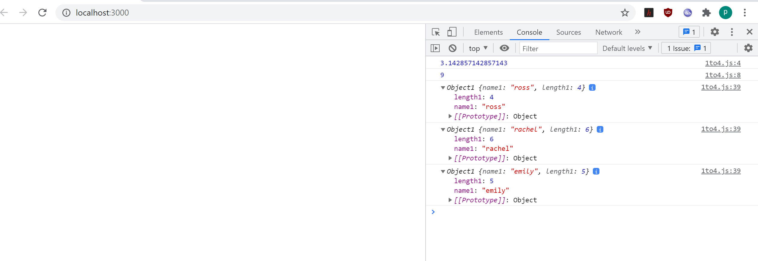

//5.a question
var add = () => 27;

//5.b
function userFriends(username: string, ...friends: Array<string>){
console.log("username: ",username);
console.log("friends: ",friends);
}

userFriends('Ross Geller','Monica Geller','Rachel Green','Chandler Bing','Phoebe Buffay','Joey Tribbiani');
console.log("----------------------------------------------------");

//5.c
function capitals(...names: Array<string>){
console.log();
for(let i in names)
console.log(names[i].toUpperCase());
}

capitals('Ross Geller','Monica Geller','Rachel Green','Chandler Bing','Phoebe Buffay','Joey Tribbiani');
console.log("----------------------------------------------------");

//6th
var laptop = "HP", model = "Spectre", deskno = 279, client='Rachel Green';
var ticket = `hi Ross, this is ${client} - deskNo.: ${deskno}, and my laptop: ${laptop},
model: ${model}, isn't working. Request replacement.`;
console.log(ticket);
console.log("----------------------------------------------------");

//7.a
let array = [2,7,6,9];
let [ele1, ele2, ele3, ele4] = array;
console.log("2nd element: ",ele2);
console.log("----------------------------------------------------");

//7.b
var organization = {
nameObj: "Emilynco.",
address: { country: "Paris", pincode:500033 }
}
let {nameObj, address: a} = organization;
console.log("deep match destructured pincode: ",a.pincode);
console.log("----------------------------------------------------");

8.

class BankAccount{
constructor (id , name , balance){
this.id=id;
this.name=name;
this.balance=balance;
}
totalBalance(){
return this.balance;

}

}
class SavingsAccount extends BankAccount{
constructor(id , name , balance , interest){
super(id ,name ,balance= balance+(balance*interest)/100);
}
}
class CurrentAccount extends BankAccount{
constructor(id , name , balance , cash_credit){
super(id ,name ,balance= balance+cash_credit);

}

}
let savingsAccount =new SavingsAccount(9,"pallavi",250000,10);
let currentAccount =new CurrentAccount(27,"pallavi",250000,1000);

console.log(savingsAccount.totalBalance());
console.log(currentAccount.totalBalance());

